

**Department of Computer Science**

# Spring 2023

**Database Management System**

**Library Management System**

**Project Report By**

**Muhammad Noman 20708 (Group Leader)**

**Group Members:**

Muhammad Moiz Nasir 20080

Maida Saeed 20712

1. **Introduction:**

The Library Management System project is a Java-based database management project designed to provide an efficient and user-friendly system to manage library operations. It automates the functions of cataloging, lending, and returning books, making it easier for library staff to manage operations and for users to find and borrow books. With its simple interface and range of features, the Library Management System provides a seamless experience for both staff and users, enhancing the library's services and improving access to knowledge and information. The project utilizes a database to store and manage data, providing a reliable and secure platform for library operations. The Library Management System project is an essential tool for any library looking to improve its services and provide a seamless experience for its users.

The system is designed to reduce manual effort and errors, making it more efficient and reliable. It provides features such as book searching, reservations, and borrowing status checks. Reports generated by the system can be used to analyze library performance and identify areas for improvement. The Library Management System is a valuable tool for any library looking to improve its operations and services.

1. **Features:**

* User-friendly interface to manage library operations easily.
* Easy to search and track books and members.
* Automated borrowing and returning of books.
* Quick and efficient book issuing and returning process.
* The system allows library staff to manage user accounts and track their borrowing history, enabling them to provide better services to users.
* The system calculates and manages fines for overdue books, providing a fair and transparent process for users and staff.
* The system allows library staff to manage multiple copies of the same book, making it easier to keep track of available copies and manage to lend.
* The system authenticates users at login to ensure only authorized users can access library resources.
* The system provides security features such as password encryption and regular backups to prevent data loss and ensure the safety of user data.
* The system provides advanced search and filter options, enabling users to easily find books based on author, title, genre, or publication date.

1. **Tools used:**

The Library Management System is developed using Java programming language and MySQL database for data management. The tools used in this project are:

* Java IDE (Integrated Development Environment) for coding
* MySQL or Microsoft SQL Workbench for designing and managing the database
* JDBC (Java Database Connectivity) for connecting Java with MySQL database
* Java Swing for creating the user interface

1. **Hardware/Software requirement:**

* Operating System: Windows XP, Windows Vista, Windows 8, Windows 8.1, Windows 10.
* Language: Java.
* IDE: NetBeans IDE.
* Storage: 4GB RAM and 120GB ROM
* Processor: Intel Pentium 4 and above

1. **Scope:**

The purpose is to automate the existing manual system with the help of computerized equipment and full-fledged computer software, fulfilling their requirements so that their valuable data/information can be stored for a longer period with easy access and manipulation of the book records. Almost in LIBRARY MANAGEMENT the records of members, new book Entry, their details, Member entries, member Enquiry, Book Enquiry, Book Return registers, etc. are maintained and manipulated. Generally, all these works are done and managed manually hence leading to the chances of human errors that may create some problems. They are used in public and private libraries as well. The rise in demand for library management software is projected to increase the sales growth of the global Library Management Software market in the forecast period, set between 2021 and 2031.

1. **ERD of the project:**

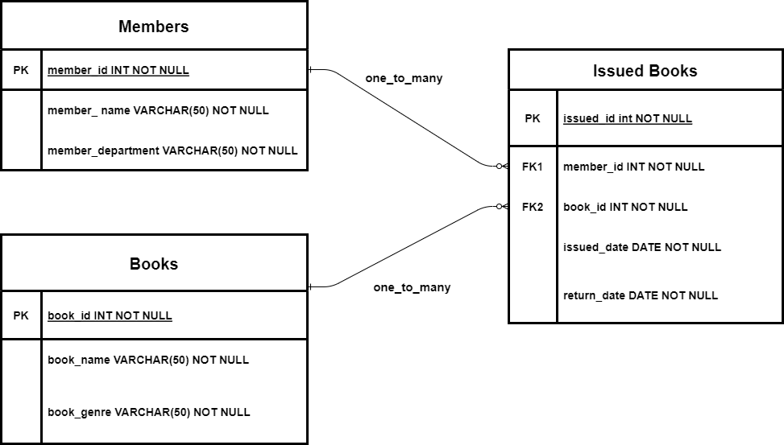

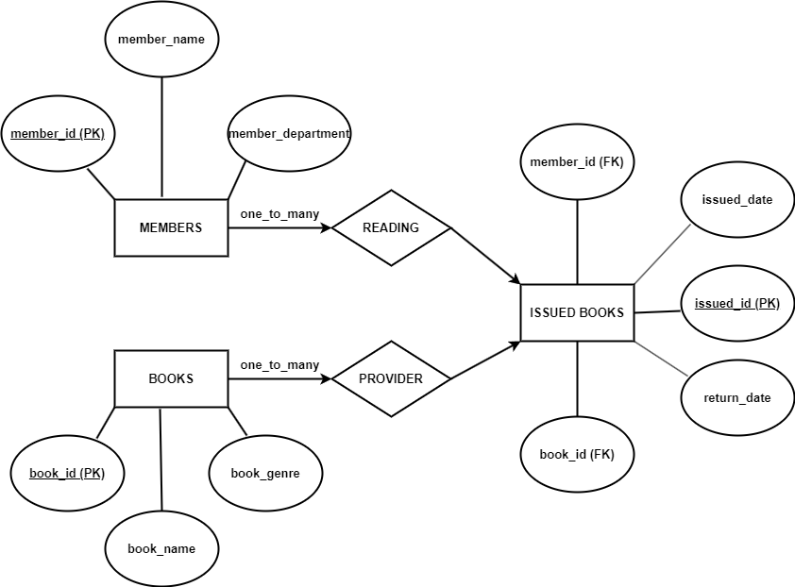

1. **Table Queries Used:**

* ***CREATE TABLE*** *Members (ID INT PRIMARY KEY, Name VARCHAR(50), Department VARCHAR(50));*
* ***CREATE TABLE*** *Books (ID INT PRIMARY KEY, Name VARCHAR(50), Genre VARCHAR(50));*
* ***CREATE TABLE*** *Issued_Books (Issued_ID INT PRIMARY KEY, Member_ID INT, Book_ID INT, Issued_Date DATE, Return_Date DATE, FOREIGN KEY(Member_ID) REFERENCES Members(ID), FOREIGN KEY(Book_ID) REFERENCES Books(ID));*
* ***INSERT INTO*** *books (ID, name, genre)* ***VALUES*** *(?, ?, ?)*
* ***DELETE FROM*** *books* ***WHERE*** *ID = ?*
* ***SELECT*** *ID, name, genre* ***FROM*** *books*
* ***UPDATE*** *books* ***SET*** *ID=? , name=?, genre=?* ***WHERE ID****=?*
* ***SELECT * FROM*** *books* ***WHERE*** *ID = ?*
* ***INSERT INTO*** *issued_books (member_id, book_id, issued_date, return_date)* ***VALUES*** *(?, ?, ?, ?)*
* ***SELECT*** *ib.issued_id, m.id AS member_id, m.name AS member_name, m.departement,*
  + *b.id AS book_id, b.name AS book_name, b.genre, ib.issued_date, ib.return_date* 
    - * ***FROM*** *issued_books ib*
      * ***JOIN*** *members m ON ib.member_id = m.id*
      * ***JOIN*** *display_books b ON ib.book_id = b.id*

1. **Screenshots:**

